Purpose
Although exercise participants will be encouraged not to fight the scenario, additional information may be incorporated into the exercise to enhance realism. The Planning Team can use the following information to supplement the exercise, if needed.

Mold
The following peripheral information can be used to support the mold scenario.

Suggested Items for the Room
- Masks to hand out
- Sanitizer and wipes
- Copy of Family and Medical Leave Act (FMLA) forms (or invite Human Resources to attend exercise so they can address questions or give input on employee assistance aspects of this scenario)

Extra Materials
- See attached Mold Report.
- If not utilizing the Mold Report, the article entitled “Health risks of mold in the workplace” provides a short overview on why mold presents a danger. The article can be accessed here: https://www.safetyandhealthmagazine.com/articles/9007-health-risks-of-mold-in-the-workplace

Images
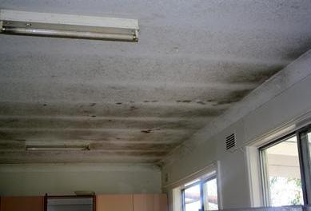
Incorporate these images into the exercise slide deck, as needed.
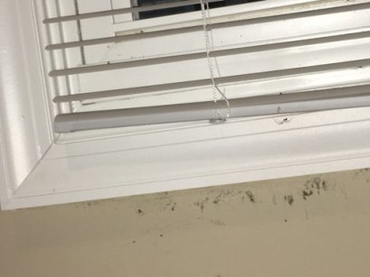

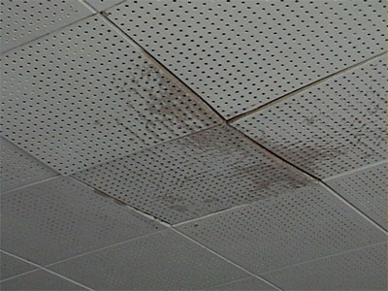
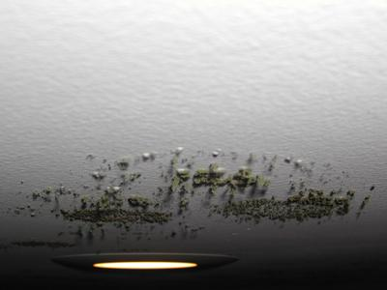

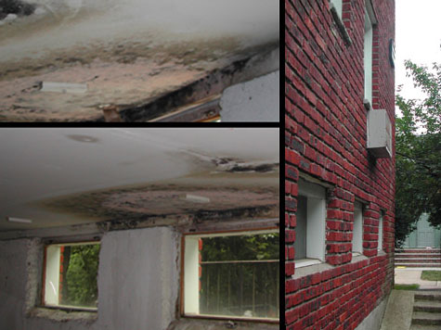

Earthquake
The following peripheral information can be used to support the earthquake scenario.

Suggested Items for the Room
- Print a simulated building crack and tape to wall.
- Place simulated debris around the room (e.g., ceiling tiles, overturned trash cans, books). Simulated debris should be placed out of the way to prevent tripping hazards. All debris should be able to readily be returned to original placement.

Extra Materials
Consider playing the following videos:
  - Earthquake In an Office - https://www.youtube.com/watch?v=c1F8eIrglUE
  - Earthquake in Courthouse - https://www.cnn.com/videos/us/2018/11/30/alaska-earthquake-hide-in-courthouse-nr-vpx.ktva
  - Major Earthquake Hits Near Anchorage, Alaska - https://www.nbcnews.com/news/us-news/earthquake-hits-alaska-triggering-tsunami-warning-n942256

Images
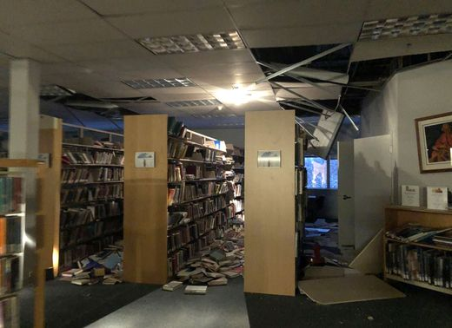
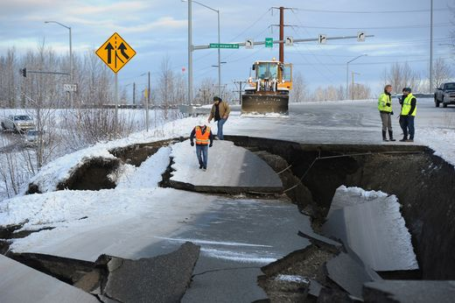
Incorporate these images into the exercise slide deck, as needed.

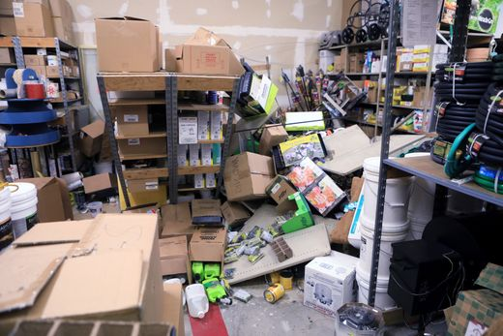

Winter Storm
The following peripheral information can be used to support the winter storm scenario.

Suggested Items for the Room
- Place a large branch in the middle of the table.
- When reading the scenario, have the evaluator create a loud crash sound.

Extra Materials
Consider playing the following videos:
  - 1999 Ice Storm - https://www.wusa9.com/video/weather/1999-ice-storm/65-8267148

Images
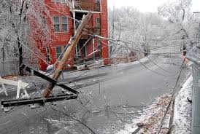
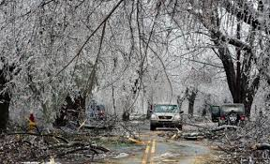
Incorporate these images into the exercise slide deck, as needed.

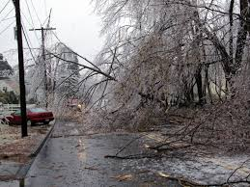
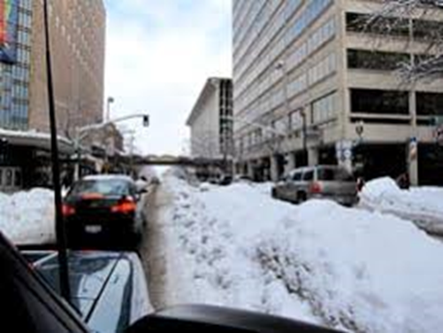

Attachment 1: Mold Report
The following is a sample mold report that can be used to supplement the mold scenario.

